
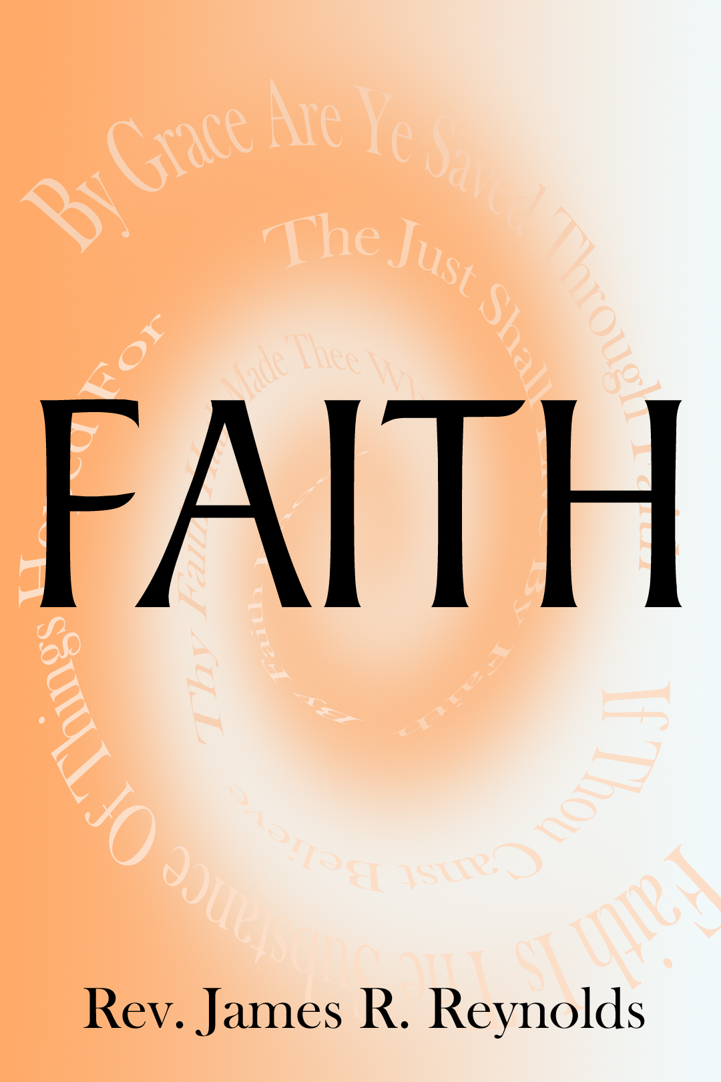


Faith—it is the Heavenly currency whereby we access the Kingdom of God. By it we receive Salvation, Sanctification, Deliverance, and Healing. In these three anointed messages, James Reynolds reveals the truths of what
Faith is, and how we apply
it to our lives.
The Action Of Faith- There is more to us receiving our promises then simply believing, but there are steps of Faith that we must take before we obtain.

The Confession Of Faith- A confession of our Faith is vital for us to obtain. If we claim the promises of God, and then speak them, we will be made whole.

The Obedience Of Faith- Not only is there thousands of promises found in God’s Word, but there are also commands that we must obey. If we believe and follow these commands, all things will be possible to us.

